**15 Feb 2019** **The Weekly Bulletin of Rotary Club of Kathmandu Mid-Town** **bc-21.2/019**

|  |
| --- |
| C:\Users\Public\Documents\RIP T1819_EN.png |

District: 3292 Web:www.rotarymidtown.org.np Club Id: 26776

**FEBRUARY IS PEACE AND CONFLICT PREVENTION/RESOLUTION MONTH**

In order to help in worldwide peace building up to 100 Rotary Peace Fellows are selected each year for participating in Master Degree programs in Rotary Peace Centers at one of its partner universities. Fellows study subjects related to the root causes of conflict and explore innovative solutions that address real-world needs. There are already more than 1,000 peace fellowship alumni spread and working in over 100 countries.

**Club’s Weekly Meeting # 1476 held on Friday 8 Feb 2019**

Guest speaker Dr Poonam Rajya Laxmi Rana gave an interesting talk on cross cultural study on ethnic community Yi of China with Tharu ethnic community of Dang Deokhuri, Nepal.

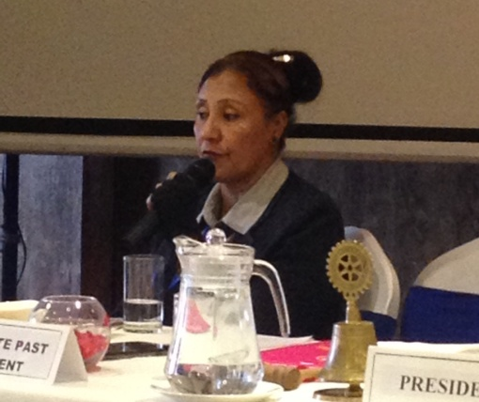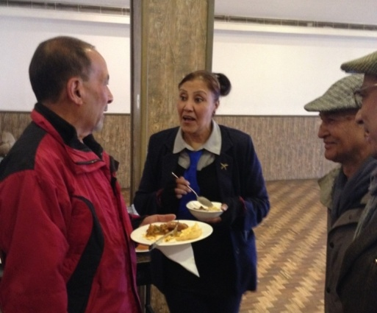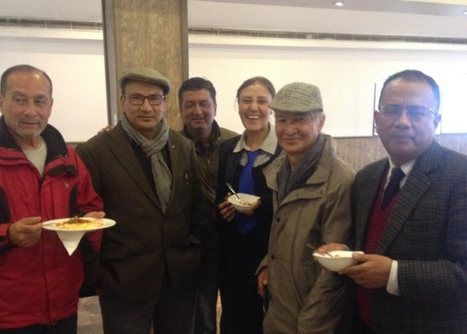

Guest speaker on session Guest speaker Dr Poonam Rana on fellowship with Mid-Towners

**Club Meeting # 1477 Friday 15 Feb**

We will have completely a new product for our weekly consumption: it’s not a regular talk program!

We are going to observe a round table discussion of four prominent participants consisting of social entrepreneur, on-line marketer, start-up business entrepreneur, and children book writer.

Round table discussion participants are: 1) Mid-Towner Rabi Karmacharya, associated with OLE, 2) Rtr Amit Bajracharya, web-marketer, associated with Bootstrap, 3) Nanda K Mandal, consultant in business development/venture creation, and 4) Pranita Chettri, children’s book writer.

They will jointly discuss on Importance of flourishing start up environment for the economic development of the country - opportunities and challenges ahead.

PE Neeva has agreed to take on the moderator role for keeping the discussion on time track!

**RID 3292 District Conference 2019:**



**11th District Conference is scheduled to be held in Butwal, 22 - 24 February 2019.**

Registration fee Spot Registration (Rs)

Rotarian/Guest 7,000

Rotarian with non-Rotarian spouse 13,000

Rotaract/Interact/RCC 3,500

Contact: Tanka P. Pokharel (Registration Sub-Committee Chair): mobile: 9857021325

**Congratulations!**

MAN’s Management Excellence Award 2019 is awarded to PP Ambica Shrestha (Chair, Dwarika Hotel). The award was handed over to her by Prime Minister KP Sharma Oli during a program organized by Management Association of Nepal (MAN) at the 38th National Management Convention held in the capital on Tuesday, 12 Feb. Congratulations!

**Institute for Economics and Peace:**

The Institute for Economics and Peace aims to create a paradigm shift in the way the world thinks about peace. Data-based research is used to show that peace is a positive, tangible and achievable measure of human well-being and development.

**Measuring Peace**

Measuring peace at the global and national level allows us to assess the social, political and economic factors that create peace. Each year the Institute for Economics and Peace produces the Global Peace Index, the world’s leading measure of national peacefulness, ranking 163 countries according to their levels of peace.

A series of national peace indices have also been developed to explore the fabric of peace at the subnational level.

*Read more on http://economicsandpeace.org*

**Construction of a School Building in Bungmati:**

Construction of school building for Tri-Ratna Cooperative School, Bungmati

On 14 Feb, Thursday, Mid-Towners - President Jo Logghe, PP Dr Lekha and TRF Chair Isabella visited the building site of the Tri-Ratna Cooperative School in Bungamati. The purpose of the visit was to show the Rotary District officials the progress that has been made so far.  This is a joint project between Nanaimo Daybreak RID 5020 (Canada, former Mid-Towner Sanjivan), RC Kath Mid-Town and the ERRRP of RID 3292. District officials in the visiting team, PDG Tirtha Man Shakya (Earthquake Relief, Rehabilitation and Reconstruction Program of RED 3292), PP Rajesh Thapa (RC Mt Everest) and PP Kumud Tripathi (RC Thamel) were very happy with the progress made so far. The school officials are energetic and enthusiastic of the progress being made. The District will soon release the second installment of the payments. Completion of the project is due in May 2019.

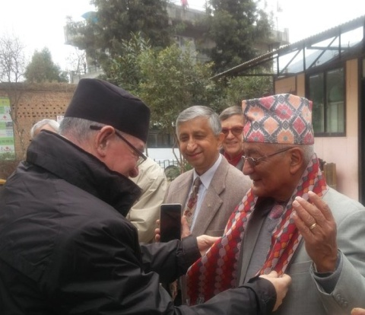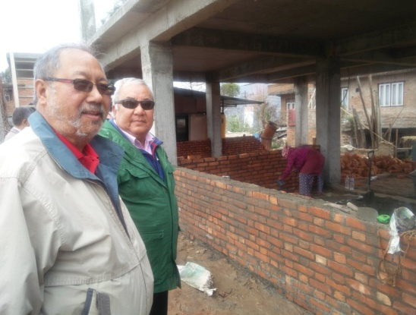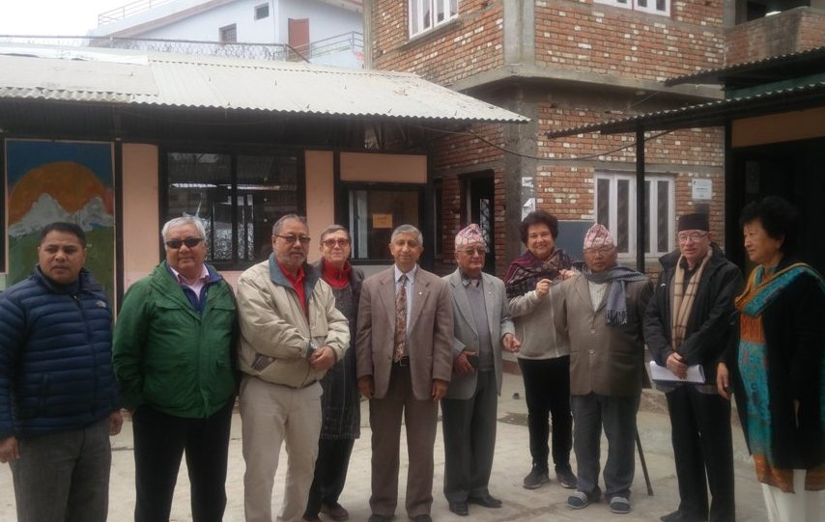

*Source/courtesy: Rtn Dr Isabella Khadka*

**Do you Know** **?**

**Suppressed sneeze causes ruptured throat!**

Let this be a warning: Do not stifle a sneeze! After a 34-year-old man in England tried holding his nose and shutting his mouth to prevent someone having to tell him 'Gesundheit,' he felt a terrible [popping sensation in his neck](https://www.livescience.com/61424-sneeze-throat-rupture.html). Doctors found an array of air bubbles trapped under his skin, mostly in his neck region, determining that the suppressed sneeze had torn a hole in the bottom part of his pharynx, or throat. The man survived and eventually healed. Two months later, he had no further health problems. But the harrowing incident led researchers to understatedly report in January that "halting a sneeze via blocking nostrils and mouth is a dangerous maneuver and should be avoided.

*Read more on https://www.livescience.com*

**A THOUGHT FOR THE DAY**

[How far you go in life depends on your being tender with the young, compassionate with the aged, sympathetic with the striving and tolerant of the weak and strong. Because someday in your life you will have been all of these.](http://www.brainyquote.com/quotes/quotes/g/georgewash106292.html)

-  *George Washington*

On Lighter Side:

One day a police officer stopped a blonde for speeding and asked her very politely if he could see her license. She replied in a huff, "I wish you guys coordinate and get your act together. Just yesterday you took away my license and then today you expected me to show it to you again!"

**Transformational Service:**

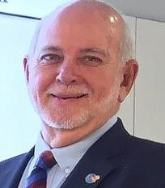

One of the most transformational projects I've been a part of involved providing a Jeep to a

group of midwives in Haiti. We had asked the midwives what we could do for them, and

they told us they needed a way to reach expectant mothers in a remote part of the country.

We supplied a Jeep, painted it pink, and put the Rotary logo on it.

Three years later, we went back to see how they were doing. They were excited by the outcomes: They told us that the mortality rate for mothers and infants in that region had dropped by 50 percent.

That's what I call transformational service.

**RI President Barry Rassin**

Please send information on club activities, progress reviews on service projects, relevant photos etc to:

BC Editor: RR Shrestha email: rryesrr@gmail.com

## 15 Feb 2019 The Weekly Bulletin of Rotary Club of Kathmandu Mid-Town bc-21.2/019